WEEK 2 STATUS REPORT

1. Week 2 Activities Completed
- Applied Wireshark display filter to isolate C2 Telnet traffic from primary attacker IP.
- Verified Telnet (Port 23) blocked via RST packet — connection termination confirmed in PCAP.
- Configured SSH as secure replacement — Port 22 LISTENING, login verified successfully.
- Deployed VLAN segmentation: Management_LAN (VLAN 10) and IoT_Isolated (VLAN 20).
- Executed all-to-all Ping test matrix to validate connectivity before and after mitigation.
- Compiled running-config from router/switch to document applied security configurations.

2. Milestones Achieved
- Telnet Port 23 successfully blocked — attacker C2 connection terminated (RST packet verified).
- SSH Port 22 operational — secure remote access replacing Telnet confirmed.
- VLAN isolation implemented — IoT devices segmented from main network.
- Firewall rule verified — external hacker IP (219.243.27.65) completely dropped at gateway.

3. Telnet Blocked — Wireshark Verification
Filter Applied: ip.src == 219.243.27.65 && tcp.port == 23
Conclusion: Attacker C2 connection from 219.243.27.65 successfully terminated

Evidence
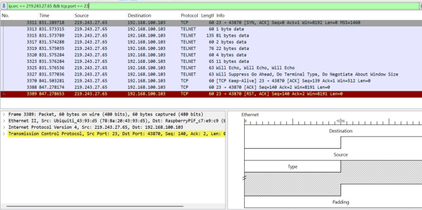

4. SSH Configuration Verification
Telnet Attempt Result: Connection refused (Port 23 blocked)
SSH Attempt Result: Login successful — Welcome to Ubuntu
Port Status: Port 22 LISTENING (verified via netstat -ant)

5. Ping Test Results
Connectivity tested before and after mitigation to confirm attacker is blocked while legitimate traffic flows normally.

Source Device | Destination Device | Before Mitigation | After Mitigation | Forensic Notes
IoT Node (Raspberry Pi) | home router (192.168.100.1) | success | success | internal basic network connectivity remains intact.
Hacker Server (219.243.27.65) | iot node (192.168.100.103) | success | failed | attacker completely dropped at the gateway firewall.
Secure PC (192.168.100.5) | iot node (192.168.100.103) | success | success | local administrative management is fully operational.

6. VLAN Segmentation Verification
Command Used: Switch# show vlan brief

VLAN ID | Name | Status | Ports
1 | Default | active | Fa0/1, Fa0/2, Fa0/3, Fa0/4
10 | Management_LAN | active | Fa0/5, Fa0/6
20 | IoT_Isolated | active | Fa0/10, Fa0/11, Fa0/12

- VLAN 1 (default) — General ports Fa0/1 to Fa0/4
- VLAN 10 (Management_LAN) — Admin/management access on Fa0/5, Fa0/6
- VLAN 20 (IoT_Isolated) — IoT devices fully isolated on Fa0/10, Fa0/11, Fa0/12

7. Router / Switch Running Configuration
Key security configurations applied and verified from running-config:

no service telnet
ip ssh version 2
line vty 0 4
transport input ssh
login local
!
vlan 10
name Management_LAN
vlan 20
name IoT_Isolated
!
access-list 100 deny tcp any host 192.168.100.103 eq 23
access-list 100 permit ip any any

